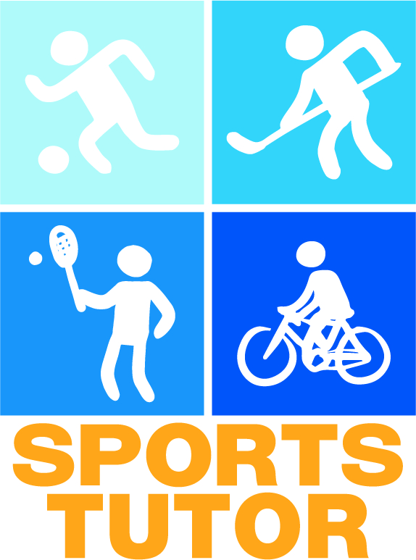

SPORTS TUTOR’S
HANDBOOK
Contents

What is sports tutoring? 3
Why is physical activity important? 3
Working as a sports tutor 4
What makes a good sports tutor? 4
What makes a good meeting with a group? 4
Tips for forming groups through physical activities 5
Affordable physical activity tips 6
Sports tutoring at your own educational institution 7
What sports tutors are required to do 7
How sports tutors are rewarded for their activities 7
Who to contact in problem situations/in relation to other matters 7
INFORMATION ON SPORTS SERVICES 8
Sports services at your own educational institution 8
Sports services in your TOWN 8
NATIONAL SPORTS BENEFITS FOR STUDENTS 8
Diagram for planning meetings 9
Space for your own notes: 10

What is sports tutoring?
Sports tutoring is peer support for physical activities. In other words, students encourage other students to engage in physical activity. Your main task, therefore, is to inspire and encourage others to participate in physical activities.

As a sports tutor, you play a key role in motivating others to engage in physical activity and to be active. You can help other students find the sports best suited to them, or gain new friends with similar interests.
On a national level, sports tutoring is promoted by the Finnish Student Sports Federation, also known as OLL. For further information on OLL’s operations and sports tutoring, visit
- the OLL website: www.oll.fi
- Facebook: www.facebook.com/opiskelijaliikunta.fi

Why is physical activity important?

From a health perspective, only 27% of students get enough exercise. In other words, there is still plenty of room to increase physical activity in the study environment! The student years are a critical time in terms of establishing a permanent active lifestyle, which is why it is important that every student finds the sports best suited to them no later than at this age. When a person moves to another town, his or her old activities are often left behind, which means that you, as a sports tutor, play a key role in sharing information about available activities.

Physical activity...
- Boosts the metabolism
- Relieves stress and tension
- Decreases the risk of developing heart or vascular diseases
- Improves the quality of sleep
- Strengthens the bones
- Makes you healthier and happier!
Being physically active also affects the memory and the ability to concentrate. Among young people, physical inactivity is linked to emotional disorders, social problems, ADHD, and behavioural disorders, among other things. According to some studies, students who are physically active also earn more study credits than those who are inactive.

The UKK Institute's Physical Activity Pie indicates how much physical activity is required from a health perspective. To get all possible health benefits out of physical activities, you should engage in activities that improve your aerobic fitness and balance, as well as increase your muscular strength, every week.

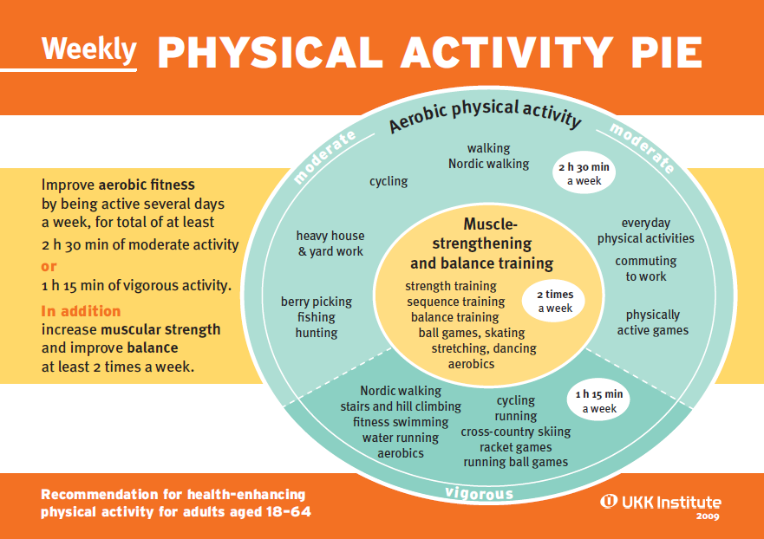

Physical activities that improve your aerobic fitness include walking, running, cycling, and swimming, among other things. Moderate physical activity for at least 2.5 hours per week is enough for beginners and those practicing health-enhancing physical activity. Those who are used to physical activity and are physically fit need more demanding physical activities to increase their physical fitness, but they only need to spend half as much time to get results, i.e. at least 1 hour and 15 minutes per week. More demanding physical activities include climbing stairs, running, skiing, racquet sports, and group activities that improve aerobic fitness, among other things.

Activities that help increase muscle strength and improve balance include, for example, gym training, ball games, and dancing. These types of physical activities are recommended at least twice a week, in addition to aerobic fitness training. You should also remember to stretch regularly in order to maintain your flexibility.

For further information on health-enhancing physical activities, visit www.ukkinstituutti.fi

Working as a sports tutor

What makes a good sports tutor?

A good sports tutor is, most importantly, ENTHUSIASTIC. A sports tutor does not have to be in top condition, or a semi-professional in any sport. The most important thing is that you are open to trying out new sports and motivating others to join in. As a sports tutor, you have the unique opportunity to meet new people and create experiences for others!

A good sports tutor:
- Is active.

- Shares information. As a sports tutor, you are in a key position to inform other students about the sports opportunities and events provided by your educational institution. New students will not necessarily be familiar with the local sports services, which is why you can help them find the activities best suited for them.

- Conveys information. A sports tutor listens to students’ wishes and feedback regarding the sports services provided by the educational institution. This puts you in a key position to convey this information to the organisers of the educational institution’s sports services, thus providing them with the opportunity to improve the quality of the sports services they provide to students.

- Is fair.

- Has the courage to ask for help. A sports tutor doesn’t need to know everything or organise everything by him- or herself. Do not hesitate to contact the contact persons for sports tutoring if you have any questions.

What makes a good meeting with a group?

A good meeting or event should be planned well in advance. You should particularly make sure to notify people of the meeting sufficiently well in advance, be it a sports event or a single meeting with a familiar group. The earlier you can mark the date in your calendar, the more likely it is to still be free.

Before the meeting...
- Decide on a topic for the meeting. Will your group play yard games or go jogging?
- Decide on the date, time, and place. You should reserve at least 2 weeks for advertising. Take into consideration other events, such as parties organised by student organisations, and try to select a place that everyone can easily find. You should attach a map to the invitation in order to ensure that the participants can find their way to the unfamiliar location.
- Book the necessary sports facility. If necessary, ask for advice from the student union or university sports.
- Advertise the meeting. In addition to the date, time, and place, your advertisement should also include what type of outfit or equipment the participant will need, and how long the meeting will last.
During the meeting...
- Be there on time! Preferably, you should arrive at the location a little ahead of time, so that you are there to welcome all the participants. Specify the meeting place precisely enough to ensure that everyone finds their way there. If necessary, call out to anyone wandering around near your meeting place looking lost.
- Make sure you bring the necessary equipment.
- Pay attention to all participants.
- Be enthusiastic yourself!

After the meeting...
- Make a report of the meeting (if necessary).
- Thank the participants. By remembering the participants afterwards, you leave them with a positive memory of the meeting. If you have their contact information, it’s easy to send a collective message thanking everyone.

Tips for forming groups through physical activities

You can get to know new people easily through activities. Getting to know the other participants is generally easy with almost any physical activity, but sometimes it is nice to take a moment at the beginning of the meeting to learn everyone’s names and fully break the ice.

Introduction game

Divide the participants into groups of 4 or 5. The members of each group stand in line next to each other. The sports tutor orders how the group must organise themselves: in alphabetical order, by height, by shoe size, by age... The fastest group wins.
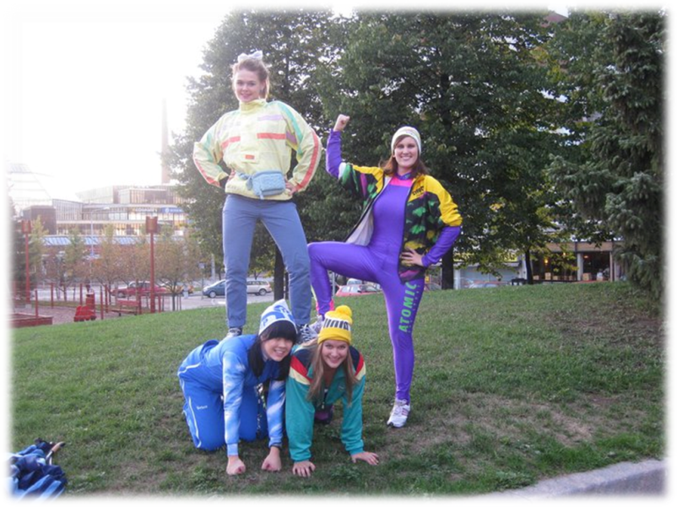
Map exercise

Imagine that the space or field where you are standing is the map of Finland – one end is South and the other North. The sports tutor instructs the participants to take their place on the map based on various facts: for instance, where the person was born, where they studied, where their grandparents are from, or where they would like to move to. You can also carry out the exercise by imagining the space as the whole world, or the city where the participants are studying.

Four feet, two hands

Divide the participants into groups. The leader of the game shouts, for instance, ‘5 feet, three hands, one head’, after which the group has to organise themselves so that they are only touching the ground with the number of limbs stated. The fastest group is awarded a point.

The princess, the bear, and the hunter

Divide the participants into two teams. Each team picks either the bear, the hunter, or the princess. The princess giggles and flutters the hem of his or her skirt, the bear growls and raises his or her hands threateningly, and the hunter points his or her rifle and shouts ‘bam’. The princess beats the hunter, the hunter beats the bear, and the bear beats the princess (compare to rock-paper-scissors).

The members of each team stand in row on each side of the centre line, facing the other team. The leader of the game counts to three, after which both teams act out the character they have chosen. The losing team turns and runs towards their own safe zone, located 10 to 20 metres from the centre line. The winners try to catch the members of the losing team. Those who are caught become members of the winning team. The game ends when every player is on the same team.

For more group games, visit the Mannerheim League for Child Welfare website (only in Finnish) at http://www.mll.fi/nuortennetti/tukarit/leikkiasema/tutustumis-vuorovaikutus-ja_ni/

Affordable physical activity tips

- An excursion to a forest or the lake shore. A group picnic in the middle of nature is an excellent way to get to know one another and to spend time together.
- Game night. You can also be active without noticing it: Twister and Wii, for instance, are fun ways to spend the evening together, and you also get some exercise in the process.
- Minigolf. A steadfast classic for sunny days.
- Visiting the educational institution’s sports facilities or others located nearby. It’s easier to visit unfamiliar facilities in a group than alone.
- Exploring the city on foot or by bike. Those who have moved to a new town appreciate help from the locals, and the locals can also explore new parts of the town by participating in a joint excursion. Destinations can be discussed in groups during training, for example – you may learn something new yourself!
- Sledding. A fun pastime in the winter.
- A skiing trip or a walk out on the ice. The spring sun, a packed lunch, and a strong layer of snow.
- Mölkky. Mölkky is a throwing game reminiscent of another Finnish game called kyykkä, and it provides stress-free entertainment.
- Yard games. Familiar childhood games are great fun even when you are older. Try, for example, Tag Bulldog; Kick the Can; skipping rope; Duck, Duck, Goose; or dodgeball.
- A trip to a playground/water park/spa/amusement park. Everyone needs to let out their inner child every once in a while. Playing on the slide allows students to forget their stress over exams and develops their balance.

Sports tutoring at your own educational institution

What sports tutors are required to do

[The educational institution’s requirements: for example, participation in training, the minimum required number of meetings, reporting…]

How sports tutors are rewarded for their activities

[INFORMATION ON HOW SPORTS TUTORS ARE REWARDED FOR THEIR ACTIVITIES. For example, does he or she earn study credits, or get a T-shirt or a certificate of honour... REMEMBER that OLL provides patches for sports tutors]

Who to contact in problem situations/in relation to other matters

[The contact information of the person in charge of the educational institution’s or student union’s sports tutoring!]

INFORMATION ON SPORTS SERVICES

Sports services at your own educational institution

[INFORMATION ON SPORTS SERVICES PROVIDED AT YOUR EDUCATIONAL INSTITUTION/WHERE TO FIND INFORMATION ON THEM: university sports, activities organised by the student union, club activities, etc.]

Sports services in your TOWN

[INFORMATION ON SPORTS SERVICES OFFERED TO STUDENTS IN YOUR OWN MUNICIPALITY/WHERE TO FIND INFORMATION. You should also mention websites such as Opiskelijan Kuopio]

NATIONAL SPORTS BENEFITS FOR STUDENTS

Students are offered various benefits and discounts for national sports events.
For further information on national sports benefits, visit the Finnish Student Sports Federation website at
www.oll.fi/edut/

Diagram for planning meetings

The topic of the meeting  (planned activity) | Place | Time and duration | Advertising (where, when) | Other considerations

Space for your own notes:

Sources (mostly in Finnish):

The Student Union of JAMK University of Applied Sciences (JAMKO): Liikuntatutorin opas [Sports Tutor’s Handbook]

The Student Union of Helsinki Metropolia University of Applied Sciences (METKA): Liikuntatutorin käsikirja 2013 [Sports Tutor’s Handbook 2013]

The Union of Upper Secondary School Students in Finland: Tutoropas 2010 [Tutoring Handbook 2010]

Finnish Student Sports Federation, Education Committee (2003): Tutorkouluttajan opus hyvinvoivaan ja liikkuvaan tutortoimintaan [Tutor Trainer’s Handbook for Healthy and Active Tutor Activities]

http://www.mll.fi/nuortennetti/tukarit/leikkiasema/tutustumis-vuorovaikutus-ja_ni/

http://www.ukkinstituutti.fi/liikuntapiirakka

