Handbook for organising sports tutoring

Content

1. What is sports tutoring? 3
1.1 The relation between sports tutoring and study ability 3
2. Sports tutoring methods 5
3. An ABC to organising 7
3.1 The annual cycle of sports tutoring 7
3.2 Financing of sports tutoring 9
3.3 Rewarding sports tutors and reporting on activities 10
4. Sports tutor education and training 10
5. OLL’s support for sports tutoring 12
References and more information (in Finnish): 13

What is sports tutoring?

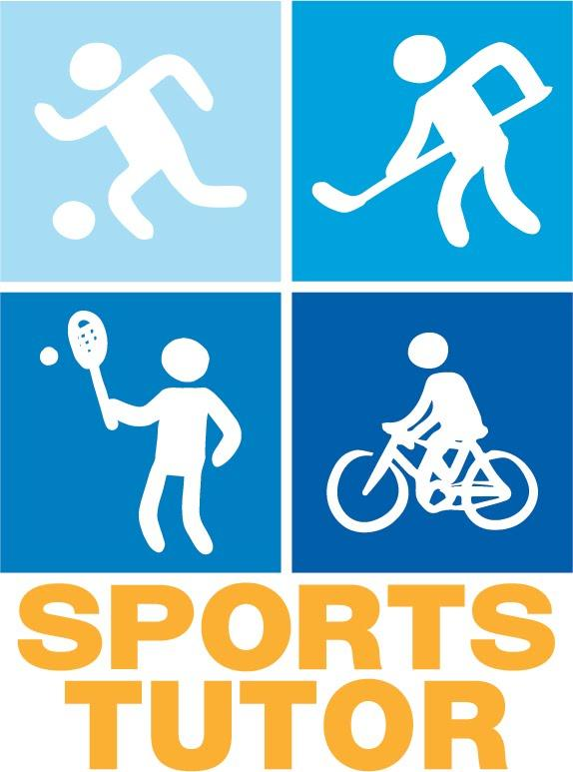
The purpose of sports tutoring is to provide instruction for student peer tutors to become sports tutors for higher education students. The tutors introduce students to the sports services organised by the higher education institution (HEI), market the sports services of the HEI and local providers as well as organise low threshold exercise for the group of tutorees, for instance trying out new sports. The activities of sports tutors support a culture of exercise and community.

The objective of sports tutoring is to also reach students who do not exercise enough with regards to their health and offer them positive experiences of sports. This encourages those being tutored to also try out other sports, for instance in an HEI environment.

Both ordinary peer tutors as well as other enthusiastic students can be sports tutors. The main thing is how enthused the student is by sports, not how sporty someone is. Sports tutors also receive training for the position.

Since sports tutors are closer to the student than those who traditionally work with exercise (employees of higher education sports, for instance), the sports tutors have a better opportunity to affect students’ choices and thoughts. Sports tutors hear, see, and serve as agents for exercise among the other students.

1.1 The relation between sports tutoring and study ability

In the tetrahedron model for study ability (see next page), study ability is seen as a student’s work ability. In this model, study ability is defined by the interactive relations between the student, their studies and their study environment, which are all impacted on by the organisational culture and environment. The most important factors affecting study ability are students’ health and resources, the study environment and community, and teaching and counselling. The better each of these factors support the student, the better the student’s study ability.

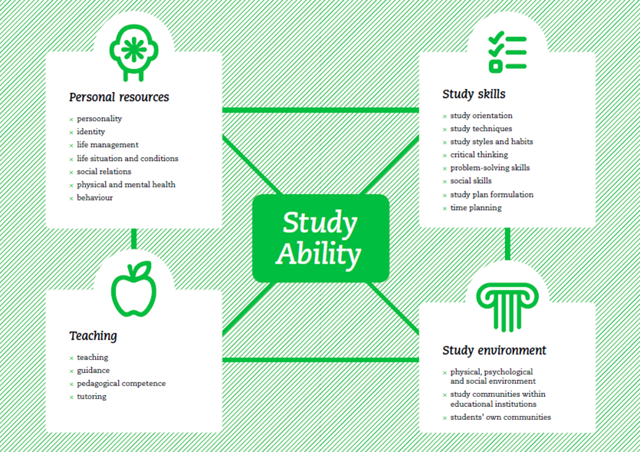

Sports tutoring can be linked to at least the study environment, teaching and counselling as well as the student’s own resources.

Sports tutoring supports the formation of new communities, offering students a possibility to engage in their study environment. Especially in the beginning of studies, partying may be a large part of students’ social life. Exercise is a good counterbalance to this. Not all students find parties to be their cup of tea and may wish for other activities. Sports tutoring can serve as a way for these students to get to know new people in a more relaxed way. At best, sports tutoring can ease the establishing of new friendships and thereby decrease feelings of loneliness and even marginalisation.

Sports tutoring introduces a new perspective also in teaching and counselling. By way of sports tutoring, students are taught to care for themselves in a holistic manner and they are introduced to new people whom they can ask for help with other questions than questions related to exercise or physical activity.

Sports tutoring supports the health and personal resources of students by providing new social relations as well as by promoting physical fitness. Exercise is an important factor for the well-being of and alleviation of stress among students. Research shows that only about 27% of students exercise enough from a health perspective. Sports tutoring therefore has an important role to play also in promoting a physically active way of life.

Methods for sports tutoring

The operative arrangements for sports tutoring vary greatly between different cities. The most significant differences concern:
- Who is responsible for arranging sports tutoring
- Who the sports tutors are
- The target group for sports tutoring
Especially in terms of who is in charge of sports tutoring, this is best decided locally, since the roles of different actors vary. Generally, it is a good idea to have a clearly defined person in charge, who is also responsible for making sure the arrangements work and are developed. In Rovaniemi, higher education sports is the body in charge of training and organising sports tutoring, whereas, for instance, the students unions at Aalto University and at Jyväskylä University of Applied Sciences organise both the regular student peer tutoring as well as the sports tutoring. If the sports tutoring is aimed at specifically new students, it may be a good idea that those in charge of sports tutoring are the same as those in charge of ordinary peer tutoring. The same channels for recruiting tutors can then be used and tutor training offered almost routinely.
EXAMPLE

At Aalto University, the student union is responsible for sports tutoring. Sports tutors are selected from among other peer tutors and provided additional training.

Higher education exercise (UniSport) takes part in training the sports tutors and supporting the activities by, for instance, offering the sports tutors period membership cards for Unisport’s services. FSHS also takes part in the trainings.

Organising sports tutoring is good to implement as cooperation between, for instance, student organisations, higher education sports, and local student healthcare. Also regional sports organisations can be of help in organising the training.

Another significant difference is who the sports tutors are. At Oulu University of Applied Sciences and Aalto University, the sports tutors are peer tutors, i.e. students themselves, who then receive additional training to serve as sports tutors. Any peer tutor can train to be a sports tutor. At the University of Turku and at Häme University of Applied Sciences, the sports tutors do not have to be ordinary peer tutors, but have been separately recruited and anyone willing can apply to be a sports tutor. The target groups for sports tutoring can also be different, not all have first year students as their target group.

Both models have their pros and cons. On one hand, when the sports tutors are also peer tutors, they are already in contact with new students, making it easier for them to reach the target group as compared to when the sports tutors are not peer tutors as well. Peer tutors usually also receive training in group dynamics and only need a short additional introduction to serve as a sports tutors. On the other hand, if any student can apply to be a sports tutor, you may have applicants who will be great sports tutors but would not have been interested in ordinary peer tutoring. These enthusiasts are excluded if sports tutors are chosen among the regular peer tutors.

In the latter case, it is advisable to include information also on group dynamics and group leadership in the training aimed at sports tutors. It is always important that sports tutors work closely with regular peer tutors in order to spread the word about sports tutoring and in order to make the activities easy to approach.

The third difference is the target group for sports tutoring. The most common target group is new students. In this case, sports tutoring is a form of peer tutoring, helping new students to adjust and to feel at home in their new study environment. This model is often used to reach especially physically inactive students. Sports tutoring is a good way to reach new students and acquaint them with the sports services at the higher education institution. However, if the target groups is physically inactive students, this needs to be addressed during training. How to motivate physically inactive students to move, and how does one identify persons matching the criteria?

The specified target group also has a bearing on how sports tutoring is marketed. If you are targeting physically inactive students, adjust the marketing to the target group. Unfortunately, there are no ready models for reaching physically inactive. You also need to think about what to do if there are more people interested than there is space in the groups. On which grounds will you choose the participants?

A few higher education institutions have tried aiming sports tutoring at especially physically inactive students. The universities in Turku and Jyväskylä first tried out sports tutoring aimed at explicitly physically inactive or lonely students. This was carried out in cooperation with the FSHS and students specifically applied for the groups. The activity of the groups varied and both universities have now converted to sports tutoring aimed at new students.

The Aalto University Student Union, however, has introduced a parallel model in cooperation with the FSHS, a course called “Lähde liikkumaan” (get moving). The objective of the course is to introduce students to new sports and people who can inspire each other to be physically active. Participants are chosen based on their applications. The course lasts for 12 weeks. During those weeks, group members meet up one to three times per week to do sports together.

An ABC to organising

After finding out the target group and who is in charge of sports tutoring at your higher education institution, you have already come a long way.
At OLL’s website you can find a check list for sports tutoring (in Finnish) and we recommend you use it. The spreadsheet lists the most important things to take into account when organising sports tutoring. Take your time filling out the checklist, since it will serve as a helpful list also in coming years.

The annual cycle of sports tutoring

The annual cycle for organising sports tutoring can be very different at different higher education institutions. Presented below is an example of sports tutoring based on the academic year and realised in a similar way to ordinary student peer tutoring. We have listed the different phases of sports tutoring in different months.

JANUARY
DECEMBER

FEBRUARY
NOVEMBER
Action!
MARCH
APRIL
MAY
JUNE
JULY
AUGUST
OCTOBER
Thank you evening for tutors
Recruiting new sports tutors
Gathering feedback of the activities
Action!
Events!
Meeting of the sports tutors

SEPTEMBER
Activities begin: positive hype!
Training

Meeting before the activities start

March:
- Recruiting new sports tutors: NB! Draw up the announcement in good time. If possible, advertise sports tutoring at the same time as the marketing for regular peer tutors. Another alternative is to aim the marketing only at the new peer tutors, for instance at the tutor camp. A good advertisement for sports tutoring includes at least the following:
EXAMPLE

The ad for sports tutors at the student union of the University of Jyväskylä in 2013 contained the following information:

What is a sports tutor?
What is expected and required of a sports tutor?
What do I get from sports tutoring?
How do I apply to become a sports tutor?

The ad ended on a positive note:
Apply to be a sports tutor, an ambassador for the joy of exercise
  - What sports tutoring is
  - The tasks of a sports tutor: Will the tutors organise events, do they tutor one group only or do they serve as information officers for higher education sports?
  - The responsibilities of a sports tutor: When is the tutor training? Is attendance mandatory? Do they need to report somehow and is there a minimum of events or activities they have to organise?
  - What do the sports tutors get in return for their work?
  - Schedule for the application and selection process.
  - And, naturally, hype the importance of the work that sports tutors do!☺
April-May:

– Selecting and training the sports tutors. If there are more applicants than places available, the selection criteria must be clear. Already when announced, require some sort of reasoning from the applicants about why they want to be a sports tutor. It is easier to select suitable tutors on the basis of such motivational letters.
NB!
We recommend that you encourage the sports tutors to work in pairs or divide them in activity pairs.

It is much easier and more fun to plan activities in pairs. Also, when you have a working pair, there is always peer support close at hand.

June-July:

– Planning activities (sports tutors) and holidays ☺

August:

– Second training or meeting for the sports tutors before the term starts. Repeat what you have agreed upon and feel the enthusiasm for it being time to start activities. A second meeting is well worth having, since it is easy to forget things during summer. Spending an evening together at the end of August works well for lifting the spirit among the sports tutors. Having a meeting at the beginning of autumn also offers an opportunity to take concrete steps to plan the activities.

September:
- Commence activities. Remember to cheer on the sports tutors throughout the term and year so they know they are doing cherished and important work. A thank you and support help the tutors stay enthusiastic and energetic.
October-December:
- Activities organised by the sports tutors.
- Meeting of the sports tutors. We recommend that you organise at least one joint meeting for sports tutors and organisers during the time activities are arranged. Arranging a get-together provides an opportunity to exchange experiences and talk about what is going on. The sports tutors need support and encouragement to stay inspired.
January-February:
- Arrange a thank you evening for those who have served as sports tutors. It is a good idea to have a common finish for the sports tutors. Also take the opportunity to collect feedback about the activities. (If the sports tutoring goes on throughout the academic year, the evening can be arranged later. Even so, we recommend a half-way check-up at some point.)
- Collecting feedback from the sports tutors and from the students who have participated in the activities. Collecting feedback helps develop sports tutoring. If possible, collect feedback from the whole community at the higher education institution.

Funding sports tutoring

It is possible to start up sport tutoring by very small means. The most important aspect is that you are able to allocate resources in terms of personnel for planning and implementation. The activities as such do not require a lot of funding. The largest expenses are the training and meeting of the sports tutors. The organiser of the sports tutoring can also offer subventions for participants if the sports tutors arrange trying out new sports outside the higher education sports.
EXAMPLE

The annual budget for higher education sports in Oulu was about 500 euro (14 hours of sports) during the first year. The second year the budget was about 1,000 euro and there were 37 sports tutors. The allocated money was used to fund trying out new sports, for instance.

However, in the autumn term of 2011, sports tutors worked an equivalent of 0.3 labour years for the good of higher education sports.

Funding may also be needed for thanking the sports tutors for their work. The most common form of reward is to offer sports tutors free access to sports services during the time span sports tutoring activities take place.

Many higher education institutions fund sports tutoring by a few thousand euros annually. Motivations you can use towards management include increasing student-centred physical activity, sports promoting study ability, activation of students and supporting an alcohol-free culture. The sports tutors are volunteers, but their work input for the higher education sport services can be very important.

Rewarding sports tutors and reporting on activities

As mentioned before, the most common way to sports tutors is to give them a sports pass or pay the sports fees for their tutoring term. Other ways to rewards tutors include:
- Study credits: If study credits are awarded for regular tutoring, why not for sports tutoring as well? Or could sports tutoring be an addition to regular tutoring, awarding students an additional study credit?
- T-shirt
- Other merchandise: higher education sports services marketing merchandise, film tickets, etc.
- Free trials combined with meetings or training
- Work/volunteer certificate and diploma
You can order overall badges from OLL to hand out to the sports tutors. The badges are available with print in Finnish, Swedish and English.

In return for the reward, we recommend that you request some sort of report from the sports tutors as well (this is a given for study credits). Different forms of reporting include individual reports, meeting form with each meeting specified, or an individual learning diary. Reporting can be done continuously or after finishing the activities. In general, reporting includes:
- What was done and when?
- How many participants took part?
- Thoughts on how well it succeeded
- What did the sports tutor learn from the experience?
- Feedback for the organisers of sports tutoring
When planning what form reporting is to be done, think about the time available for the coordinator of the sports tutoring has available. If you demand lengthy reports, someone has to have the time to read, and preferably also comment on, them.

Sports tutor education and training

Common points for planning education and training hold true for planning for sports tutoring as well: Think about relevant content from the participants’ point of view, book appropriate facilities, and include numerous breaks.

What can the relevant content then be? For instance:
- Information on the benefits of sports and information on students’ habits in terms of physical exercise.
- Information on sports motivation
- Introducing the sports facilities and services of the higher education institution and near-by facilities
- Teaching group dynamics and group leadership skills
- Hands-on planning of activities
- Physical exercise or sports
Although most of the participants are probably somewhat motivated in terms of physical activity, it is nevertheless a good idea to first explore how and why students exercise or do not exercise. This way, sports tutors gain insight into why their work is important.

The most important part of the provided training is presenting the local options for physical activity and sports. In addition to the sports services at the higher education institution, it is advisable also to find out what other sport services are on offer locally or at least inform the sports tutors about where they can find more information about them. Even if the sports tutors are locals, they do not necessarily know about all local possibilities for exercise, but it is something students may ask them about.

Reserve enough time for planning the actual activities. This can be carried out in small groups, for instance. Group work makes it easier to think together and exchange ideas with others.

If the sports tutors are not peer tutors as well, we recommend that you include group dynamics and development as a topic as well. Although the sports tutors are not de facto coaches or supervisors, it is useful for them to have an insight into the basics of leadership.

Training should also make sure sports tutors have an opportunity to bond with each other. Group spirit inspires, creates a positive hype and helps tutors manage as peer support is readily available. At best, the sports tutors will get to know new people from different subject areas, which in turn increases interdisciplinarity at campus. Support the community spirit among the tutors by arranging meetings throughout the year.

Arrange active meetings and get-togethers. If possible, combine the training or meeting with trying out a new sport or do some physical activity together. And, if you are already on your way with sports tutoring, ask former sports tutors to come and share their experiences.

If you have not given training or workshops before, for instance MLL has a handbook for trainers (in Finnish) with tips for planning and implementing training. The handbook can be downloaded here:

http://www.mll.fi/julkaisut/verkkojulkaisut/jarjestotoimijoille/

EXAMPLE

A good outline for a sports tutor training can look like this (from OSAKO’s training in spring 2013):

16:00 Introduction, presentations
16:30 Finnish Student Sports Federation (OLL) and sports tutoring on a national level, Vesa-Ville Väänänen (OLL)
16:40 Higher education sports services in Oulu and wellbeing services at Oamk,
Aki Hentilä (Oulu higher education sports services)
17:00 The student union OSAKO and sports tutoring at Oamk
17:30 Coffee break
17:50 Health of higher education students, based on the survey of higher education students’ health 2012,
Vesa-Ville Väänänen (OLL), Pinja Laukkanen (OSAKO)
18:20 From the sports tutors, about study ability, and group work,
Jari-Pekka Kanniainen (OSAKO) and former sports tutors
19:30 Final discussion and end of training

References and more information (in Finnish):

http://ayy.fi/blog/2013/02/11/lahde-liikkumaan-kurssi-starttaa-26-2/

http://jyy.fi/opiskelijalle/liikunta/liikuntatutorointi/liikuntatutoriksi-hakeminen/

The union for upper secondary students SLL (in Finnish), Tutoropas 2010

Finnish Student Sports Federation OLL (2003) (in Finnish): Tutorkouluttajan opus hyvinvoivaan ja liikkuvaan tutortoimintaan

Project report on the project Lähtenyt liikkumaan (in Finnish)

