Are students faring well?

Preliminary comparison of student wellbeing in Finland and Sweden, based on the Firstbeat Lifestyle Assessment

Anni Liina Ikonen & Jussi Ansala
Finnish Student Sports Federation (OLL)
June 2020

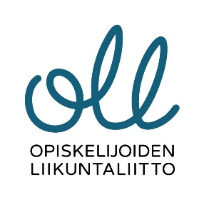
Contents

Project background 1
Firstbeat Lifestyle Assessment 2
Project implementation 5
Co-operation 5
Selection of participants to the assessment 5
Key findings, reflections and follow-up questions 6
Background information 6
Reflection and follow-up questions: 8
Answers to the preliminary questionnaire: 9
Reflection and follow-up questions: 11
Main results of the Lifestyle Assessment 11
Stress 11
Reflection and follow-up questions: 12
Exercise 12
Reflection and follow-up questions: 13
Recovery 13
Reflection and follow-up questions: 14
Research subjects' views of the results 16
Reflection and follow-up questions: 18
Finally, who won the match? 18
The Swedes were ahead in every event - we need a rematch! 18
Sources 19

Project background
The Finnish Student Sports Federation (OLL) and the Swedish Student Sports Federation (SAIF) as organisations dedicated to sport have traditionally focused on promoting physical activity and exercise. However, in this project we have expanded the perspective to examining the overall wellbeing of higher education students. In addition to exercise, the project involved studying everyday stress, sleep and sleep quality, as well as recovery during studies and free time.

Firstbeat was selected as the partner to conduct research on the wellbeing of university students, as the technology it has developed has the potential to produce accurate and diverse data on bodily functions that affect wellbeing. This technology is based on measuring the heart rate, since a large number of body functions are directly or indirectly related to the regulation of heart function. Based on this pilot with Firstbeat, it would be possible to further develop wellness services for university students, particularly regarding recovery and analysis based on individual data.

Another interesting broadening of the perspective relates to the fact that the Firstbeat Lifestyle Assessment method enabled the collection and analysis of data not only in Finland, but also on the wellbeing of higher education students in neighbouring Sweden. Although the number of students measured is very small and is, by nature, a sample (38 students in total), it enables small-scale and preliminary comparisons between the countries. Finland and Sweden also have an almost 100-year history of annual competitions in athletics (Finland-Sweden Match/Finnkampen) - so why not compete in the promotion of student wellbeing, too!

The structure of the report is as follows. To begin, a brief description of the Firstbeat Lifestyle Assessment method and the implementation of the project. Then, a summary of the measurements for Finland and Sweden, as well as key results, observations and comparisons based on them. Finally, the observations and results are interpreted and considered from a variety of perspectives. The report ends with ideas for making use of the project and for future developments.

As background, it should also be stated that this project took place at a historically exceptional time, in spring 2020. In Finland, measurements were finished in the beginning of March, while in Sweden, measurements were recorded until the start of April, at which point all Europeans - including students - were reasonably aware of the danger posed by the new COVID-19 virus. It may be the case that the state of emergency did not fully affect the measurement data, but this cannot be said for certain.

Firstbeat Lifestyle Assessment
Lifestyle Assessment is a tool developed by Firstbeat Technologies to evaluate stress, physical activity and recovery patterns and promote better wellbeing and resilience. Lifestyle Assessment is sold at Firstbeat webstore and by a number of wellbeing and health professionals and service providers in Finland. Firstbeat is expanding their services in Sweden as well. According to Firstbeat:

- Lifestyle Assessment is a measurement that analyzes heart rate variability to produce accurate and multifaceted information about bodily states and functions.
- Lifestyle Assessment provides individualized insights and methods for better stress management, sufficient recovery and appropriate physical activity.
- The 24-7 assessment in daily life brings out lifestyle factors that support or impair wellbeing and good performance, and helps identify the causes behind overload, stress or poor recovery.
- Lifestyle Assessment is carried out by attaching two electrodes on the skin typically for three consecutive days (including two working days and one day off).
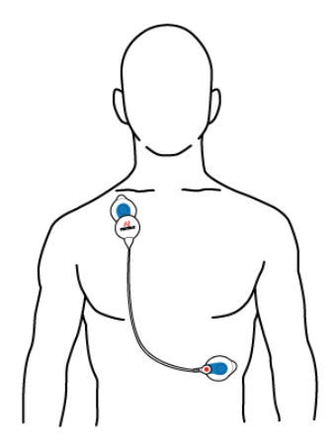
Image source: https://partners.firstbeat.com/en/learning-center/

Firstbeat Lifestyle Assessment shows how your body reacts to differents situations:
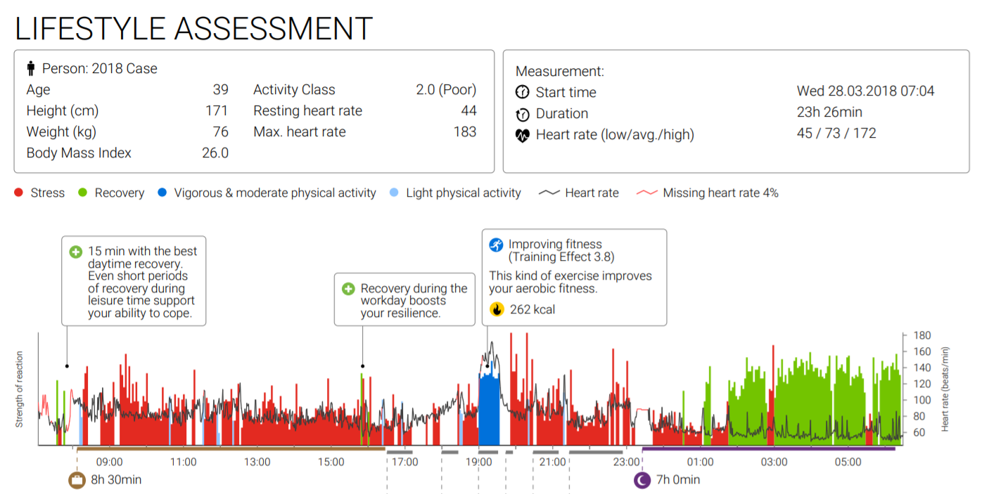
Image source: https://www.firstbeat.com/en/wellness-services/wellness-professionals/technical/#example-reports

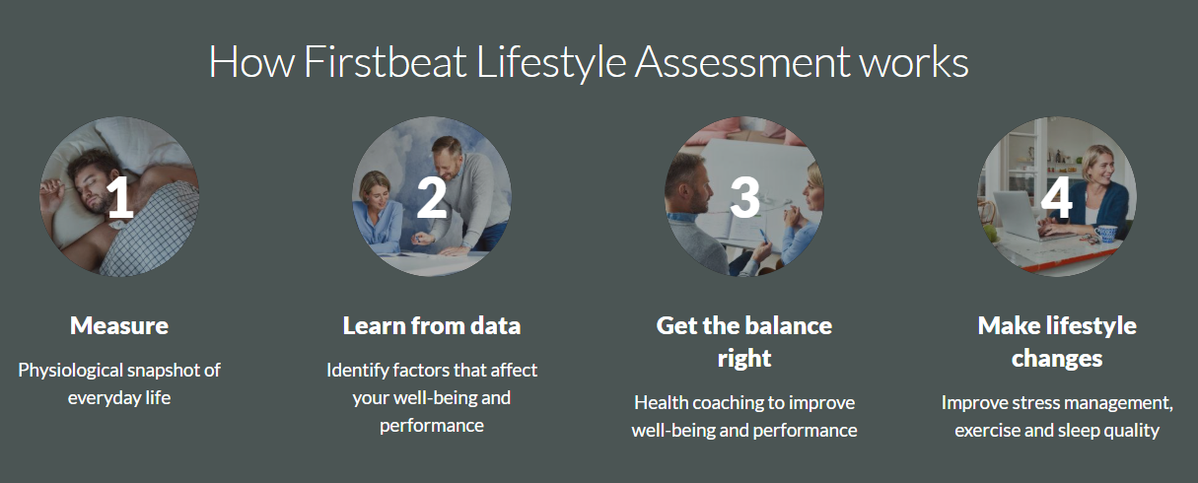

Image source: Individual Well-being

The students who participated in the assessment considered their results interesting and even surprising in some parts. There are some quotations from them below. We will analyse the students’ reactions more profoundly in later parts of this report.

“I was surprised by how much good recovery there was during my sleep period although I felt like I slept poorly.“ (a Finnish student)

“I was surprised that I don’t get any good recovery during the day.“ (a Swedish student)

“[I was given valuable information about] me having a stress reaction ongoing for a major part of the day. I can’t explain the reasons other than that I found out that exercise and physical activity of all kinds are counted as stress factors.” (a Finnish student)

“[I was surprised] that according to the assessment I was stressed during the evening when actually I felt the calmest.” (a Swedish student)

Project implementation

Co-operation
In Finland the Lifestyle Assessment was carried out in co-operation with Satakunta University of Applied Sciences (to be precise: with the accessibility research group, CampusMowe Wellness Services and the physiotherapy degree programme). The general principles of the co-operation were negotiated with senior lecturer Kati Karinharju who is a member of the accessibility research group. The Lifestyle Assessments themselves were run by a physiotherapy student Saara Benlamine with a group of SAMK students from various fields of study. She was instructed by SAMK lecturer Mari Törne.

In Sweden the main partner was the Swedish University Sports Federation (SAIF), the counterpart of OLL. SAIF was represented by employees Cecilia Olsson and Fredrik Ginsby and a sports development student Jonas Fridell. Jonas, who completed his internship at SAIF, ran the Lifestyle Assessments similarly to Saara in Finland.

Selection of participants to the assessment
To obtain a comprehensive understanding of student wellbeing, the aim was to have students participate from a wide variety of backgrounds and life situations. The decision was taken to measure a total of 20 participants from each country in accordance with the available resources, so as to obtain the most accurate and diverse data possible, while maintaining anonymity. Technical challenges arose as the measurements began, which is why only 18 of the measurements in Finland were successful enough to be included in the overall analysis.

The application form used to seek research participants included questions related to age, gender (female/male/other/prefer not to answer), family situation, field of study, graduating class and exercise habits. These variables were chosen because they were expected to play a role in wellbeing. The aim was to make the group of research participants as diverse as possible in light of the variables.

In Finland, all of the research participants were recruited among Satakunta University of Applied Sciences students, who applied in droves to take part in the project. In Sweden, due to lower levels of interest, research participants were taken from two higer education institutions: the Stockholm School of Economics, a university, and Bosön Idrottsfolkhögskola, which would be known in Finland as a liberal adult education institution (kansanopisto in Finnish).

Assessment Dates
Finland: from February 13th 2020 to March 1st 2020
Sweden: from February 27th 2020 to April 1st 2020

Key findings, reflections and follow-up questions
This section contains a summary of the measurement results of the Firstbeat Lifestyle Assessment in both countries, as well as the project and group summaries based on them. First, the participants' background information and answers to the preliminary questionnaire are presented. Then, the Lifestyle Assessment' key findings on stress, exercise and recovery are presented. Finally, we examine how the students themselves view the Lifestyle Assessment' findings and results.

Background information
Background information of the students who took part in the assessment was gathered on the sign-up questionnaire.

Self-reported level of physical activity (scale 1-5):
- Finland: average value 3,6
- Sweden: average value 3,7
Gender distribution
- Finland: 12 females, 6 males
- Sweden 10 females, 10 males
Age:
- Finland: average 26 years
- Sweden: average 23 years
Body Mass Index
- Finland: 25,9
- Sweden: 23,7
Field of study:
- Finland: business 33 %, physiotherapy 22 %, miscellaneous 45 % (nursing, social services, engineering, logistics, tourism etc.)
- Sweden: business & economics 45 %, sport development 55 %
Class:
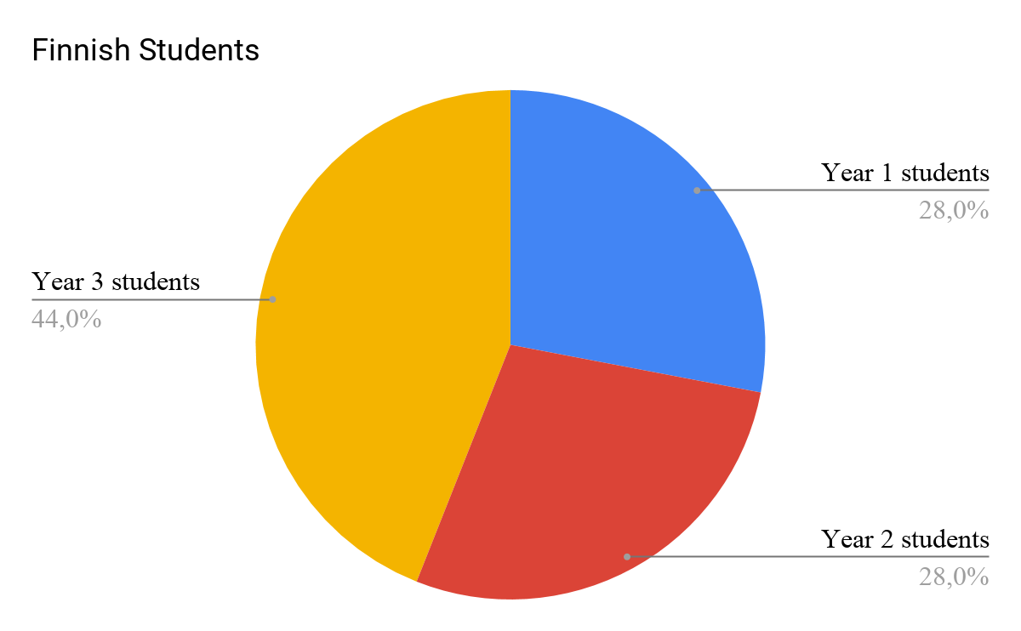
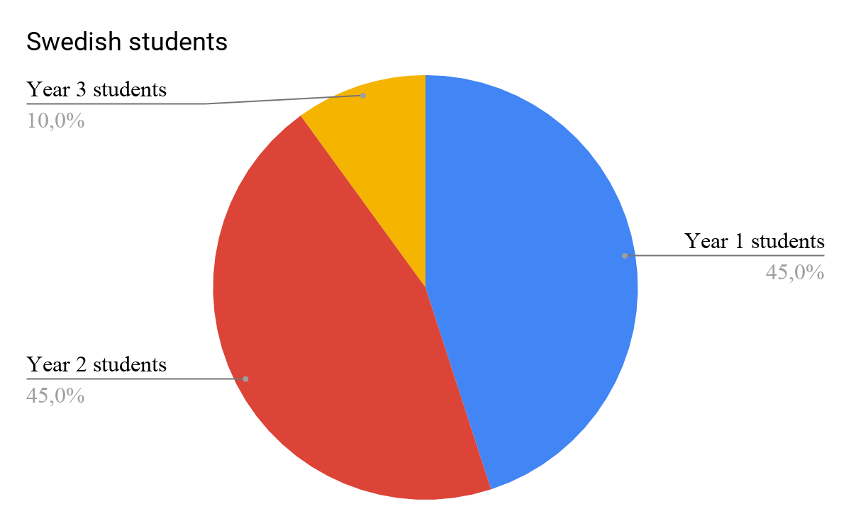

Civil status:
- Finland: 82 % were in a relationship
- Sweden: 45 % were in a relationship

Reflection and follow-up questions:
In terms of their background information, there are both similarities and differences in the profiles of the Finnish and Swedish students who took part. The self-evaluated physical activity level had almost exactly the same value: 3.6 for the Finns and 3.7 for the Swedes. (This does not, of course, mean that the measured level of physical activity is the same, as the results will show later.)
There was a reasonable difference among the research subjects in gender distribution and the average body mass index: among the Finns, female subjects were more numerous, while the Swedes were split evenly between male and female. The average body mass index was higher for Finnish students (25.9), which can be classified as mildly overweight. The average body mass index of Swedish students was 23.7, which is classified as normal weight based on an upper limit of 24.99.
There was also a difference in age; the Finnish students were slightly older than the Swedish students. The age difference between the research subjects is also reflected in the fact that, among the Finnish students, there were clearly more third-year students, and among the Swedes, the majority were first-year students.
The research subjects also differed in terms of the profile of the city in which they study; all of the Swedes lived in the Stockholm region, while the Finnish subjects lived in a smaller municipality, Pori. Differences in marital status can be explained in part by differences in the places of residence in question; larger cities may have fewer people living in relationships than in smaller localities. On the other hand, the difference in marital status may also be explained by the average age difference of three years.
There was considerable similarity in the fields of study among the research subjects. Business studies are the largest of the individual fields of study (33% and 45%) in the student samples from both countries. Physical activity is also a strong topic for students in both countries; more than half of the Swedish students study a major called Sport Development and 22% of the Finns study physiotherapy. It can be assumed that students of physical activity, exercise and sport value physical activity and sport more than average, which may also be reflected in their measurement results, especially in terms of physical activity. The measurements suggest that this hypothesis is correct.
In terms of background information, it should also be noted that all of the Finnish students were studying at a university of applied sciences. Among the Swedish students, half studied at a folk college (folkhögskolan) and half at a university. At least in Finland, the wellbeing, health and other related behaviours of students at universities of applied sciences have traditionally been weaker than those of university students. However, in terms of exercise and physical activity, the difference between university of applied sciences and university students has clearly balanced out in Finland in recent years.

Answers to the preliminary questionnaire:
The preliminary questionnaire, which is part of the Firstbeat Lifestyle Assessment, is an online questionnaire that maps out the starting points for research subjects' wellbeing. The preliminary questionnaire is filled out before the measurement device is attached to the subject’s skin. The survey consists of statements that respondents answer using one of five options on the Likert scale, ranging between completely agree, somewhat agree, I don't know, somewhat disagree and totally disagree. In the summary of responses below, responses that start with "completely" (agree or disagree) and "somewhat" (agree or disagree) are grouped together. For example: the 32% of respondents who said they do not feel stressed includes both those who completely agreed and those that somewhat agreed with the statement.

Physical activity:
- Finland: 77 % reported they are physically active enough for their health.
- Sweden: 90 % reported they are physically active enough for their health.
Alcohol consumption:
- Finland: 88 % reported they consume alcohol in moderation (77 % completely agree).
- Sweden: 90 % reported they consume alcohol in moderation (50 % completely agree).
Stress:
- Finland: 32 % did not feel stressed.
- Sweden: 60 % did not feel stressed.
Recovery:
- Finland: 83 % reported that their days include recovering moment and breaks.
- Sweden: 60 % reported that their days include recovering moment and breaks.
- Finland: 61 % felt that they get enough sleep.
- Sweden: 70 % felt that they get enough sleep.
Personal wellbeing:
- Finland: 73 % feel they are able to affect things related to their own health.
- Sweden: 100 % feel they are able to affect things related to their own health.
- Finland: 88 % feel well/healthy.
- Sweden: 95 % feel well/healthy.

Reflection and follow-up questions:
In interpreting the responses to the self-assessment preliminary questionnaire, it is important to be aware of the tendency in health sciences studies to answer questions about health behaviour in a socially favourable manner. For example, it has been noted that when asked about exercise habits, respondents have a conscious or unconscious tendency to lay claim to more extensive or otherwise better physical exercise habits than what they practice in reality.

On the other hand, it should be noted that, when responding to the questionnaire, the students were probably aware that the same subjects would be measured and verified more objectively. This may have lessened the emphasis on social acceptability, as it can be assumed that the respondents wanted their responses to cohere with the actual situation.

Main results of the Lifestyle Assessment
The Firstbeat Lifestyle Assessment is based on the examination of a number of key health factors. These are stress, physical activity and recovery (which also includes the amount and quality of sleep). The main findings and results for Finnish and Swedish students are presented below. Finally, some reflections and interpretations of the observations are made and follow-up questions presented.

Stress
Stress is a normal physical reaction and there is no need to avoid it, but sufficient recovery is required in order to achieve a balance.

Average share of stress per day:
Finland: 55 %
Sweden: 45 %

Reflection and follow-up questions:
According to Firstbeat, the normal amount of stress is about 40-60% per day. For both countries, the share of stress appears to be within normal limits. For some reason, however, Finnish students are more stressed than Swedes. Firstbeat user database average is 50 %.

Exercise
Firstbeat uses a recommendation from the American College of Sports Medicine (ACSM) which states that regular exercise of moderate intensity for at least 30 minutes a day is required to maintain good health. This recommendation differs from the international physical activity recommendation used in general health promotion work in Finland, which makes a distinction between exercise that improves endurance and exercise that promotes muscle tone and movement. Firstbeat's Lifestyle Assessment gives a good result (60 p.) for those who exercise intensively for around 30 minutes every day or engage in lighter exercise for longer periods.

Average physical activity index:
Finland: 54/100
Sweden: 64/100
Moderate to vigorous physical activity:
Finland: average 20 min / day
Sweden: average 26 min / day
Sufficient physical activity for health:
Finland: 42 % were physically active enough for their health.
Sweden: 56 % were physically active enough for their health.

Reflection and follow-up questions:
For both countries, the preliminary questionnaire gave a much more positive picture of the research subjects' level of physical activity. In the preliminary questionnaire, 77% of Finns responded that they were exercising enough to maintain health, while the measurement data indicated that only 42% were doing so. For Swedes, the difference was almost the same: according to the preliminary questionnaire, 90% exercised sufficiently to promote good health, but the measurement data reduced this share to only 56%.

It should be noted that self-assessments are almost always based on hunches, which are rendered even more inaccurate by the fact that not all respondents can have been aware of the related criteria for assessing adequacy of exercise.

Although the physical activity results were lower than the self-assessment data, the Finnish respondents still have reason to celebrate. The measured physical activity of the selected research subjects exceeds the average of all Finnish university students by 9 percentage points in terms of engaging in adequate physical activity for maintaining health; according to a study conducted by OLL and Otus (Recommendations for University Sports 2018), the number of students exercising sufficiently is only 33%. However, it should be noted that the criteria in the latter study are broader regarding a number of qualitative measures, and may therefore be more difficult to fulfil.

Recovery
Measuring recovery is an important aspect of Firstbeat's Lifestyle Assessment. If recovery capacity is normal, around 7 hours of sleep will usually ensure sufficient recovery each day.

Insufficient sleep is caused by a variety of disruptive factors. The most common are alcohol, illness, pain, stress, poor fitness and hard exercise, or other activities that activate the body before bedtime.

Measured sleep time
Finland: average 8h 19min
Sweden: average 7h 58min
Average share of recovery during sleep
Finland: 57 % (36 % had a good amount, 36 % had a poor amount).
Sweden: 71 % (55 % had a good amount, 17 % had a poor amount)
Average amount of recovery during work/study time:
Finland: 5 min / day
Sweden: 18 min / day
Average amount of recovery during free time
Finland: 47 min / day
Sweden: 1h 5min / day
Average share of recovery per day
Average value 26 % in Firstbeat user database. Firstbeat recommends at least 30%.
Finland: 23 %
Sweden: 30 %
Measured quality of recovery (RMSSD)
Finland: 57
Sweden: 69

Reflection and follow-up questions:
The measurement results for Swedish students are consistently at least slightly better than those of Finnish students; Swedish students experience less stress during the day and exercise more than Finnish students. Swedes still accumulate more daily recovery time in both their free time and work/study than Finnish students and, in addition, the quality of recovery is better for Swedish students. What makes this observation interesting is the fact that, in the preliminary questionnaire, a much larger portion (83% vs. 60%) of Finns reported that their days included moments for recovery and breaks.

The only analysis variable in which Finland outperforms Sweden is the time spent sleeping; Finnish students sleep an average of 21 minutes longer per night than Swedish students. On the other hand, Swedes were better able to use the shorter sleep time to their “benefit”, as their recovery rate from the sleep cycle is clearly higher than that of Finns. For Finnish students, clear polarisation in the recovery results is also of concern: on the one hand, there are many who have good sleep recovery, but there are also many who have worryingly poor sleep recovery. This finding is also supported by responses to the preliminary questionnaire, which found that a higher proportion of Swedes (70%) felt they were sleeping enough in comparison to Finns (60%).

The examination and treatment of recovery-related matters is particularly interesting and important in the sense that this theme has not been widely discussed in health studies of students, at least in Finland. This lack is at least partly due to the challenge involved in defining the concept of recovery. According to Firstbeat, quality of recovery is indicated by a key figure describing heart rate variability,
RMSSD, with high variation values linked to good recovery. Low values, in turn, indicate adverse changes or weak recovery related to the autonomous regulatory system.

University students may also display particular characteristics related to recovery and the ability to recover. At least in Finland, years spent studying and the student culture have traditionally been associated with moderately high alcohol consumption. As mentioned above, alcohol consumption is usually indicated by clearly reduced sleep recovery. This may be surprising to students who feel that they have had sufficient sleep of sufficient quality, but the measurements indicate poor recovery. In the Lifestyle Assessment, the possible positive and negative effects of alcohol consumption by students would certainly be an interesting theme for further research. In future research, the connection between alcohol consumption and wellbeing indicators could be examined through individual wellbeing analyses, but in this report they have mostly been omitted to protect the subjects’ anonymity.

Particularly among students, an irregular daily rhythm is a factor (in addition to studies and the related stress) which may hamper recovery. Years spent studying are associated with young people becoming independent and often moving from their childhood homes to a new place. Independence gives them freedom, but also requires becoming proactive in finding a suitable daily rhythm in a new environment. In such a case, very positive factors, such as physical exercise, may hamper recovery if exercise is done very late in the evening. This observation arose in the research subjects' own reflections.

It should be stressed that no absolute conclusions can be drawn on the basis of this project. The number of students measured is small, and the study did not involve country-specific cohorts but individual samples. In other words, the students who participated in the project were those who were “available” for the measurements. In spite of these limitations, the findings can point us in the right direction. Could it be, for example, that Finnish students systematically score lower for wellbeing than Swedish students? And if so, what factors lead to this and how might the situation be improved for Finnish students? Finding the answers to these questions and, for example, identifying statistical links or even causal links between various wellbeing indicators, may be possible on the basis of more extensive and systematic research work.

Research subjects' views of the results
The basic idea of a Lifestyle Assessment is not only to provide participants with measurement data on factors affecting their wellbeing, but also to substantially support change to improve their own wellbeing. A key question can be asked from this change-focused viewpoint; how do students view their own Lifestyle Assessment results? Below are quotes reflecting the views of both Finnish and Swedish students, experiences of the benefits of the analysis, and the lifestyle changes it inspired.

Most frequently set goal was related to:
- Finland: sleep & recovery, physical activity
- Sweden: sleep & recovery

Perceived benefits from Firstbeat Lifestyle Assessment

“Maybe I got in a better mood when I got facts on how well my body is functioning.“ (a Finnish student)
“The results were very intriguing and they were very informative.” (a Finnish student)
“I realised, how important recovery is for me.” (a Swedish student)
“I no longer stress about sleep, I trust it recovers me well.” (a Finnish student)
“I realised that I should not exercise so late because then I am so worked-up when going to sleep.” (a Swedish student)
“I was most interested in stress, recovery and sleep. I got valuable insights from these perspectives.” (a Swedish student)
"The Assessment was very intriguing in terms of statistics. Recovery is important so that you can keep up with your personal life and exercise.” (a Swedish student)

Lifestyle changes inspired by Lifestyle Assessment

“I have added some aerobic exercise. Other stressfactors are not changeable because they are tied to a certain schedule.” (a Finnish student)
“I need to make sure that I get enough recovery during the day.” (a Swedish student)
“I will take it easier in the morning so I don’t cause too much stress to myself.” (a Swedish student)

Reflection and follow-up questions:
The findings on recovery and stress seemed to generate the most interest and insights in students who took part in the study. Awareness of recovery and the related products and services has become more common in the consumer market only in recent years. For this reason, it is understandable that recovery-related observations were regarded as new and interesting. For many years, heart-rate monitors have been used much more commonly to measure exercise, which is why, for the purposes of this project, we can assume that exercise-related insights have been much less widespread.

The importance of recovery to both holistic wellbeing and physical exercise for improving health is also highlighted in the fact that, the UKK Institute, a Finnish centre for research and expertise, first published physical exercise recommendations referring to restorative sleep in 2019. When combined, adequate sleep and physical exercise have optimal health effects, as recovery during sleep contributes to the health effects of physical activity.

Finally, who won the match?

The Swedes were ahead in every event - we need a rematch!
The measurement results of Swedes and Finns suggest that, at least for the students who participated in the project, Swedes are generally in clearly better condition than Finns. The Swedes fared better in statistics across the board. Although the Finns slept longer, even that was not enough for better recovery results, as they had a significantly lower quality of sleep recovery than the Swedes.

The quality of recovery plays a major role in overall wellbeing, as students' lives are often stressful, exhausting, busy and occasionally include alcohol consumption, leaving little time for sleep or relaxation. It would be good for students to take full advantage of breaks from regular life.

It is clear that students should not be left alone with the challenges they face related to recovery. Multi-professional changes are required in the post-secondary sector to improve students' overall wellbeing. The next step could be a more systematic study of how Finnish students recover and whether they do something differently to students in Sweden. Students who are faring well learn more effectively and remain fit to work for longer – caring for students' wellbeing is in the interests of all of us!

Sources
Firstbeat Lifestyle Assessment results and anonymised summaries
Firstbeat -website materials:
https://partners.firstbeat.com/fi/oppimisymparisto
https://www.firstbeat.com/en/wellness-services/individual-wellbeing/
https://www.firstbeat.com/en/wellness-services/wellness-professionals/technical/#example-reports
https://www.firstbeat.com/fi/tuki/ohjeet/
Recommendations for University Sports (2018):
https://oll.fi/assets/uploads/2018/02/Korkeakoululiikunnan_suositukset-2018_nettiversio.pdf
UKK-institute:
https://www.ukkinstituutti.fi/liikkumisensuositus/aikuisten-liikkumisen-suositus

